Curso de Inglês

Professor: Luis Felipe

Aluno: Luiz Perciliano

Programa: Class#9_2021

**Sumário**

1. Semana 33 – de 16 de agosto a 22 de agosto 3

2. Semana 34 – de 22 de agosto a 28 de agosto 3

3. Semana 35 – de 28 de agosto a 04 de setembro – Unit 16 4

4. Semana 36 – de 04 de agosto a 0x de setembro – Unit 16 5

5. Semana 38 – de 20 de setembro a 0x de setembro – Book 2 Unit 1 10

6. Referências 10

# **Semana 33 – de 16 de agosto a 22 de agosto**

Unit 10 = <https://www.youtube.com/watch?v=MpkVVksji4Y>

**Estudo dia (17/08/2021):** WorkBook, Unit 10, exercise 3.

**Estudo dia (18/08/2021 00:29h):** WorkBook, Unit 10, exercise 4 – OK

**Estudo dia (18/08/2021 22:38h a 23:12h):** WorkBook, Unit 10, exercise 5 at 10 – ok

**Unit 11**

I AM GOING TO HAVE A PARTY- INTERCHANGE INTRO 5TH EDITION UNIT 11 AUDIO PROGRAM

<https://www.youtube.com/watch?v=YQtXPmLAoEM&t=5s>

Listen unit eleven complete.

**Estudo dia (19/08/2021 23:14h a 00:20h):** WorkBook, Unit 11 exercise 1 at 2

**Estudo dia (20/08/2021 23:44h a 00x:37h):** WorkBook, Unit 11 exercise 3 at 5.1

Interchange INTRO 5th edition - Unit 11A 👉👉 SUBSCRIBE 👈👈

<https://www.youtube.com/watch?v=ngCd0g8QrEM&list=PL2eIVQX0_SVcB-neEUAK6OrN0z0Xf9FTS&index=21>

**Estudo dia (21/08/2021 08:00h a 10:00h):** Aula no Zoom com teacher e guys.

**Homework:** Lesson 10, 11 and 15 cap 7b em diante.

It made lesson 10 until 11 5.1

# **Semana 34 – de 22 de agosto a 28 de agosto**

**Study day (23/08/2021 22:31h a 23:27h):**

WorkBook: **: Unit** 11, exercice 5.2 at exercise 7

Book, Unit 15 exercise 7 B em diante (page)

Refazer toda a lição 7

**Study day (24/08/2021 22:47h a 23:16h):**

Drops - OK

Book, Unit 15 exercise 7 B em diante - OK

Refazer toda a lição 7 – OK

To make 8 – Word Power (vídeo 12:00minutes)

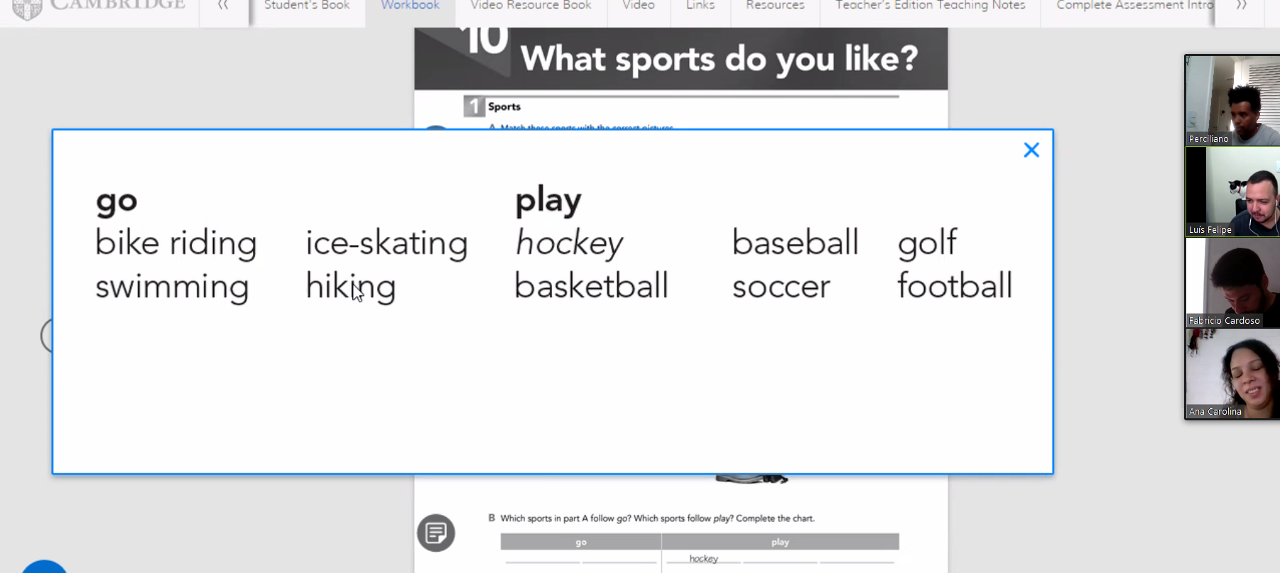

Unit 15 links

Interchange INTRO 5th edition WHERE WERE YOU BORN?

* WHERE WERE YOU BORN ?

<https://youtu.be/OI0vkiif5uI> (listen in 23/08/21)

listen again and to make exercise seven

* Unit 15A - <https://youtu.be/tSmaZdmrZ0U?list=PL2eIVQX0_SVcB-neEUAK6OrN0z0Xf9FTS>
* Unit 15B - <https://youtu.be/yLJ-kqkfsL8?list=PL2eIVQX0_SVcB-neEUAK6OrN0z0Xf9FTS>

Book, Unit 15 exercise 7 B (page) em diante

**Homework: Unit** 11, exercice 5.1 and study unit 15 book 7b em diante. (23/08/2021 = OK)

# **Semana 35 – de 28 de agosto a 04 de setembro – Unit 16**

**Study day (28/08/2021 08:13h a 10:02h) – Botafogo-RJ**



Correct Units workbook 10 and 11.

**Study day (30/08/2021 23:20h* a 31/08/2021 00:50h) – Botafogo-RJ**

Workbook, unit 12, make until exercise 6.

To homework, to make workbook unit 11, 12 and 13

Unit 12 –

<https://www.youtube.com/watch?v=vEOuo1JC1aA> (listen 30/08/2021)

<https://www.youtube.com/watch?v=tIqNtQJGCEY&list=PL2eIVQX0_SVcB-neEUAK6OrN0z0Xf9FTS&index=24>

<https://www.youtube.com/watch?v=_FM3Ww-ZrbU&list=PL2eIVQX0_SVcB-neEUAK6OrN0z0Xf9FTS&index=25>

Unit 16

ESTARLING SILVESTRE

CAN I TAKE A MESSAGE ? interchange intro 5th edition unit 16 audio program

<https://www.youtube.com/watch?v=bbcjRqiyhnE>

Teacher Wilkins

<https://www.youtube.com/watch?v=YYQCuXjjvLg&list=PL2eIVQX0_SVcB-neEUAK6OrN0z0Xf9FTS&index=31>

<https://www.youtube.com/watch?v=rf5vDhOXkqI&list=PL2eIVQX0_SVcB-neEUAK6OrN0z0Xf9FTS&index=32>

**Study day (31/08/2021 23:26h a 01/09/2021 00:33h):**

To homework, to make workbook unit 12 exercise 7 and 8

**Study day (01/09/2021 22:18h a 01/09/2021 00:33h):**

Unit 13 - HOW DO I GET THERE ? - <https://www.youtube.com/watch?v=T4OR8SfyOcQ&t=19s>

To homework, to make workbook unit 13 - exercise 1 letter A and letter B.

**Study day (02/09/2021 22:00h a 03/09/2021 00:24h):**

To homework, to make workbook unit 13 - all

**Study day (03/09/2021 22:58h a 04/09/2021 00:30h):**

See every video <https://www.youtube.com/watch?v=bbcjRqiyhnE>

I need to make exercices of book and workbook.

# **Semana 36 – de 04 de agosto a 0x de setembro – Unit 16**

**Study day (04/09/2021 08:10h a 10:02h) – Botafogo-RJ**

Initial conversation Teacher

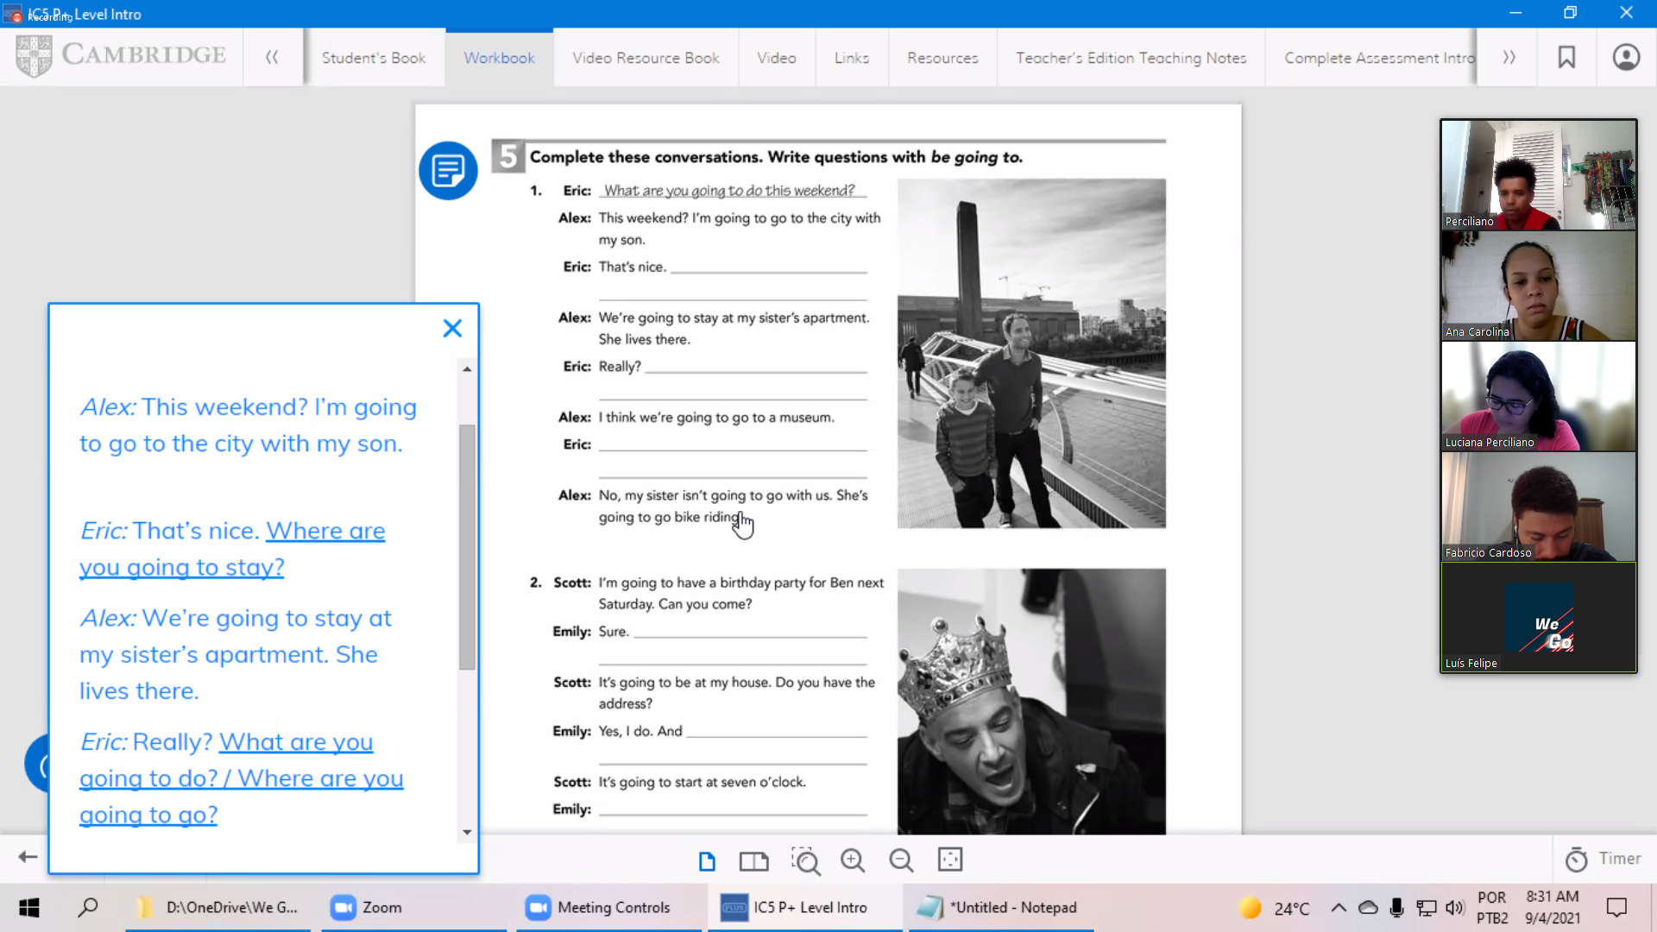

-

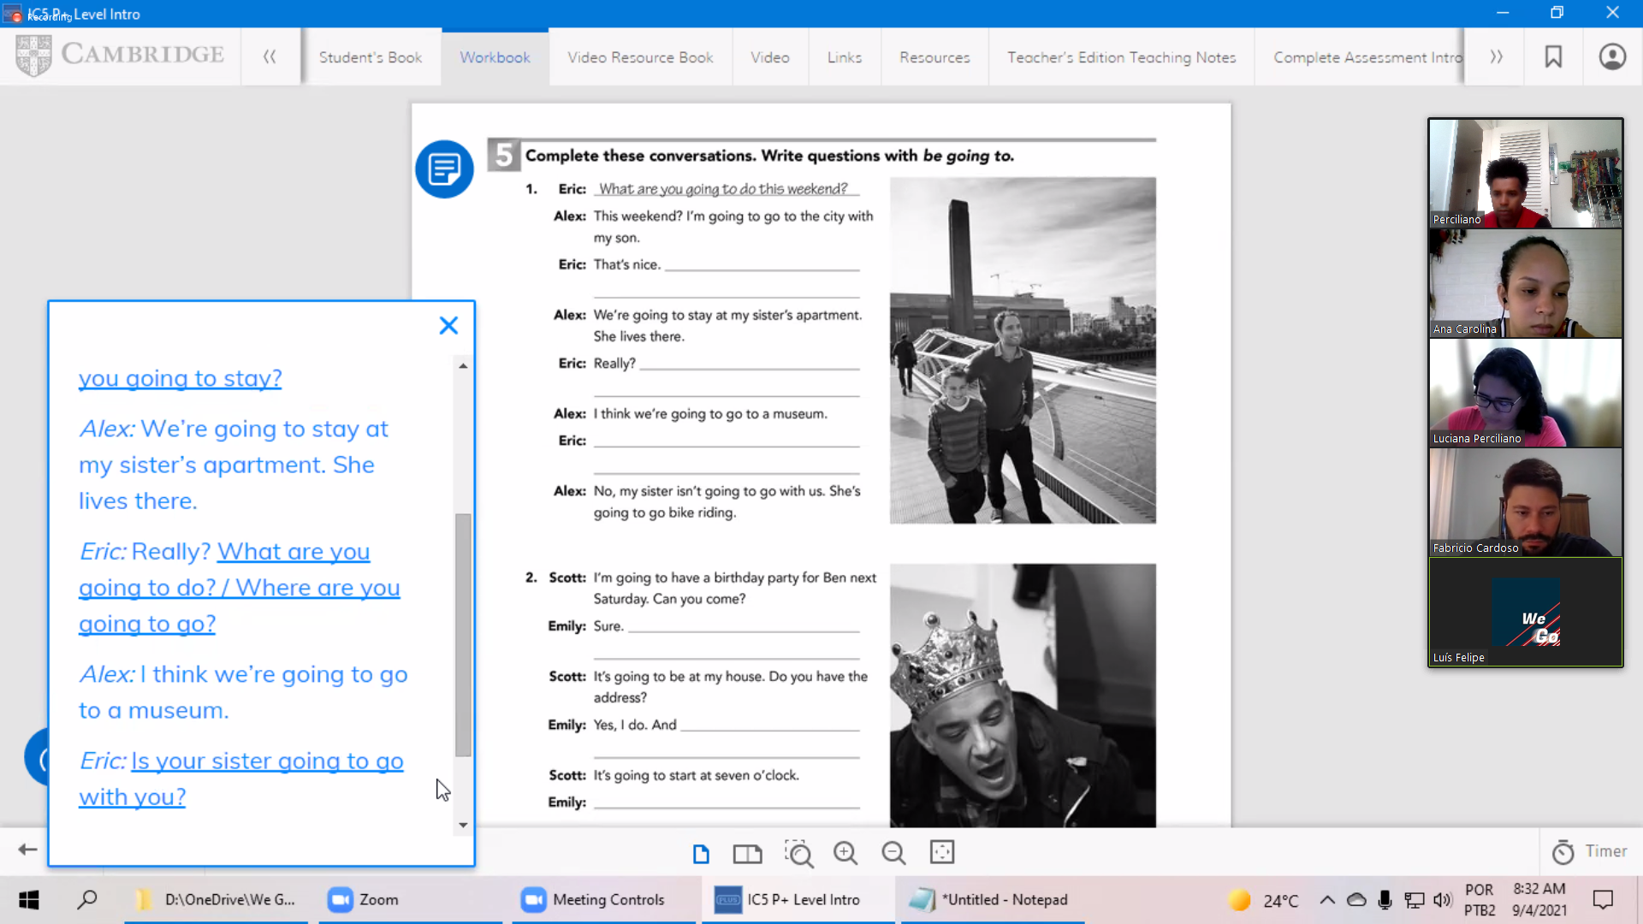

-

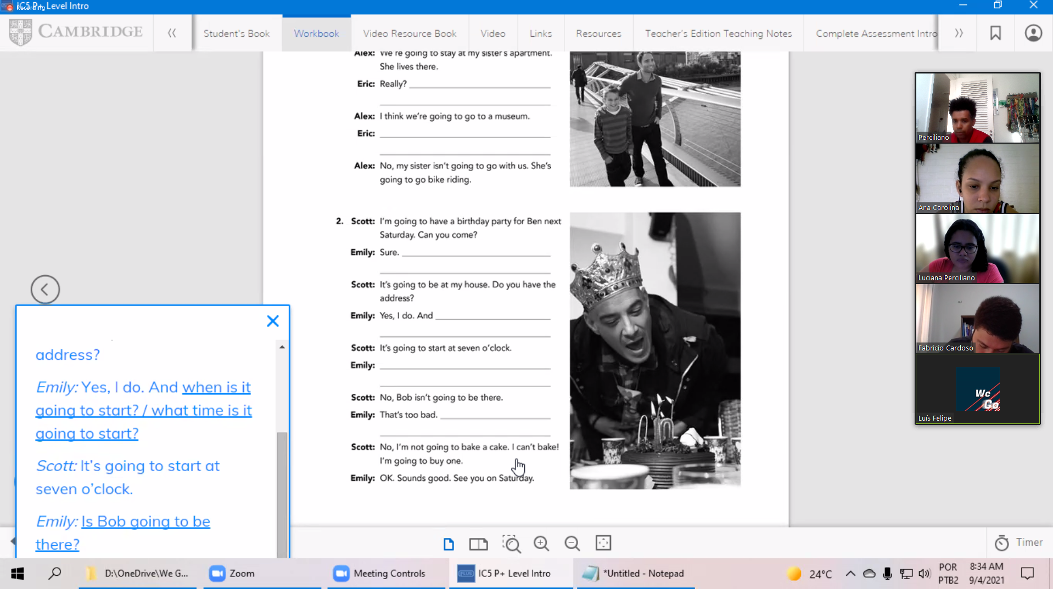

-

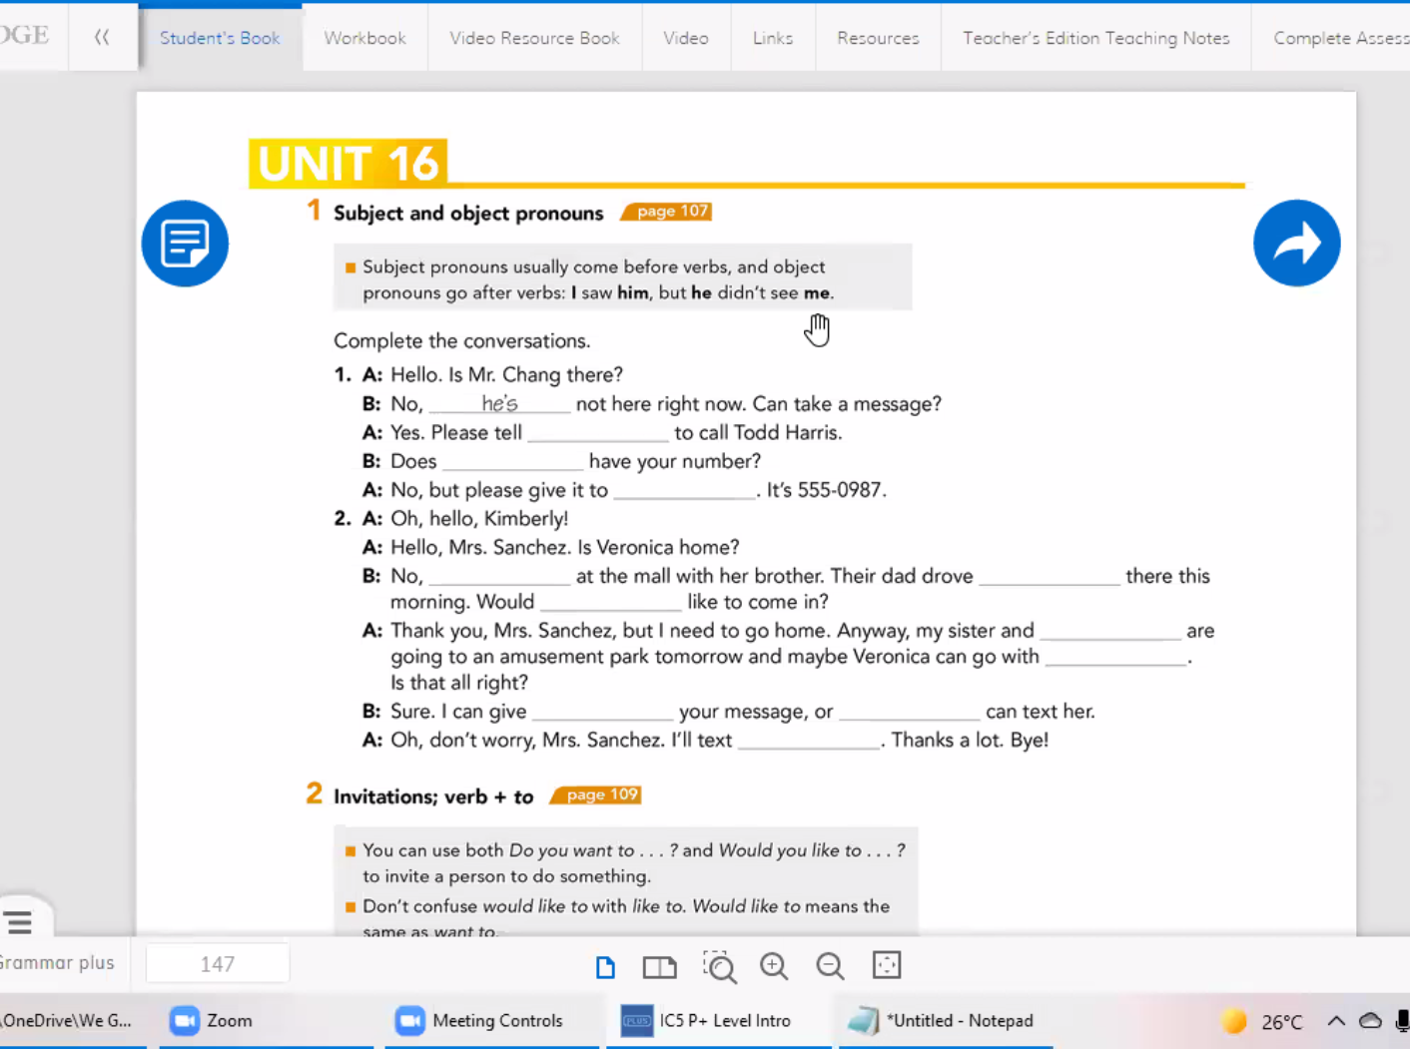

-

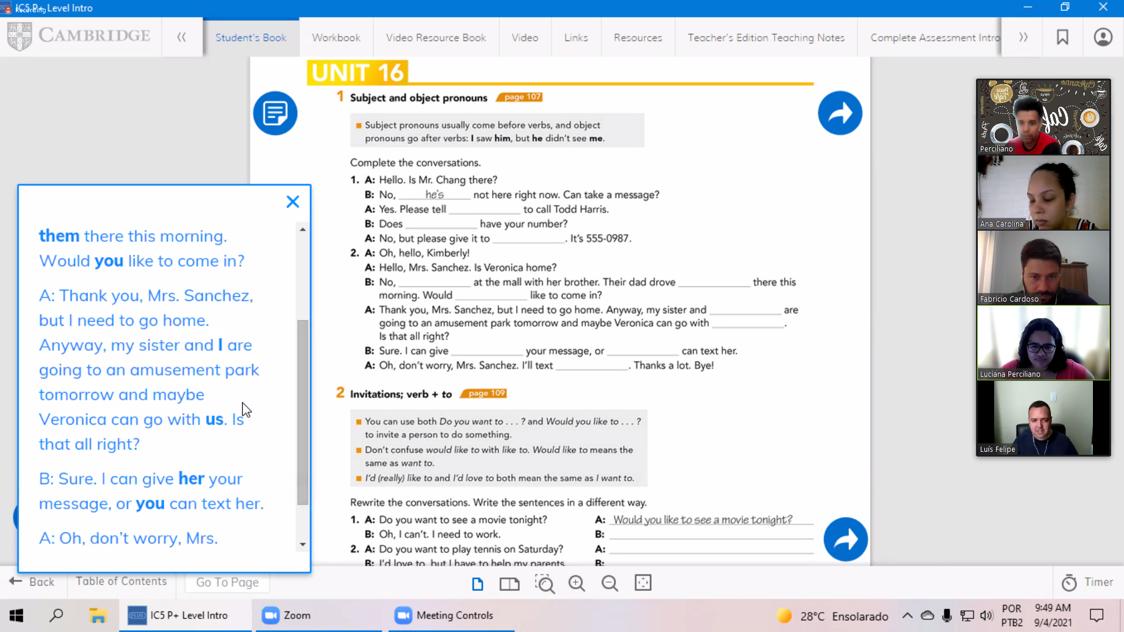

-

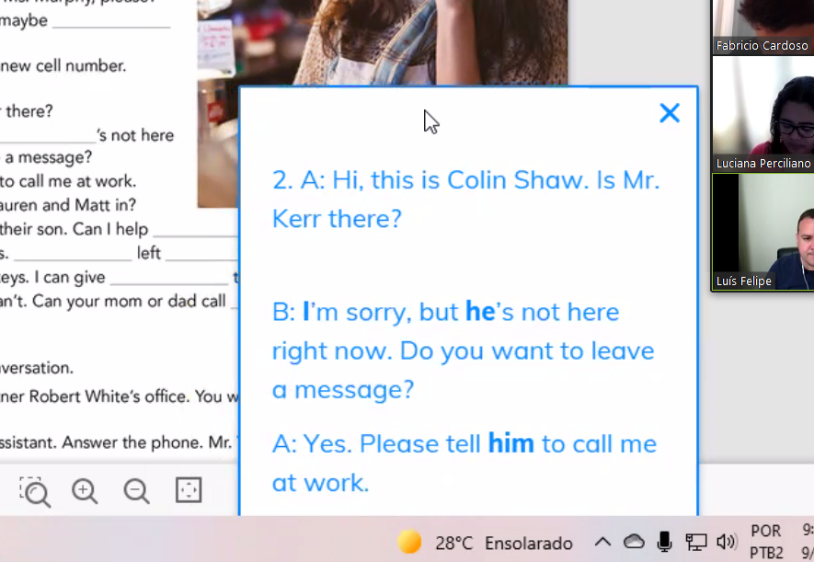

-

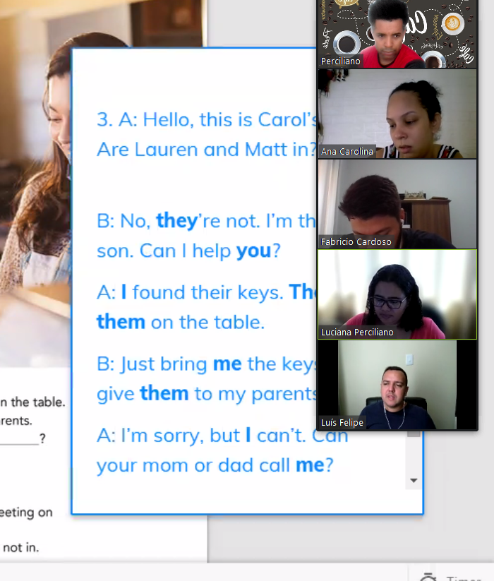

-

Study unit 16 until exercise 4 (grammar focus and grammar plus).

To make exercises unit 16 after exercise 4 from book and workbook unit 14, 15 and 16.

# **Semana 38 – de 20 de setembro a 0x de setembro – Book 1 Unit 14, 15 and 16**

Aula do dia 18, com prova, faltei

Unit 14 – I had a good time.

<https://www.youtube.com/watch?v=aLJj-jnJMR0>

* Book page 92 – 99 | pdf page 98
  + 1 Snapshot – page 92
  + 2 Conversation – page 92
  + 3 Grammar Focus – page 93
  + 4 Pronunciation – page 92
  + 5 Grammar Focus – page 94
  + 6 Speaking – page 94
  + 7 Conversation – page 95
  + 8 Grammar Focus – page 95
  + 9 Listening – page 96
  + 10 Word Power – page 96
  + 11 Interchange – page 94
  + 12 Reading – page 94
  + Units 13-14 – Progress check – page 98 – 99
* Workbook page 79 a 84 | pdf 82 - 87

**Study day (22/09/2021 19:57h a 01/09/2021 00:33h):**

* Busuu
* Drops - OK
* Duolingo
* News in levels
* To homework, to make workbook unit 14, 15 and 16

**Study day (23/09/2021 19:10h a ):**

* Busuu - OK
* Drops - OK
* Duolingo Italy - OK
* News in levels
  + Spain’s ugliest tomato
* To homework, to make workbook unit 14, 15 and 16
  + Finished unit 14
  + Finished unit 15 until exercise 5.

Unit 15 – Where were you born?

<https://www.youtube.com/watch?v=OI0vkiif5uI>

* Book page 100 – 105 | pdf page 106 - 111

1. Snapshot
2. Conversation - I was born in Brazil
3. Grammar Focus
4. Pronunciation
5. Conversation
6. Grammar Focus
7. Listening
8. Word Power
9. Speaking
10. Interchange 15
11. Reading

* Workbook page 85 a 90 | pdf 88 - 93

Unit 16 –

<https://youtu.be/bbcjRqiyhnE>

**Study day (Saturday - 25/09/2021 xx:57h a xx:33h):**

**Book 2 – Playlist**

[**https://www.youtube.com/watch?v=uOx7h3Ew0xI&list=PLrE-TRIPaiR6jbFFzng5UD9fT8emtBz7R**](https://www.youtube.com/watch?v=uOx7h3Ew0xI&list=PLrE-TRIPaiR6jbFFzng5UD9fT8emtBz7R)

# **Semana 39 – de 26 de setembro a 02 de outubro – Book 2 Unit 1**

**Study day (22/09/2021 19:57h a 01/09/2021 00:33h):**

# **Referências**

Teacher Wilkins -

<https://www.youtube.com/channel/UCtjDh5Cp7Va9qh3CMnsfLrA>

Lessons record: <https://1drv.ms/u/s!AvGAHmvAFyVsk9A6Meosg1Znza2zIg?e=eof2xh>

<https://app.languagedrops.com/?_branch_match_id=969359611060418607>

<https://www.newsinlevels.com/>

https://www.duolingo.com/learn